**# Lexathon**

**Computer Architecture Group Project**

**How to run:**

1. Save all files including the Mars emulator to the same folder.

2. Open source files using Mars. (validationModule, timerandPointModule, gameModule, Driver, checkDictionary)

3. Go to Settings and enable Initialize program counter to global 'main' if defined.

4. Click to the Driver.asm file and compile to run. If you try to compile and run from other files it will error.

5. The program should show you a menu like the image shown below.

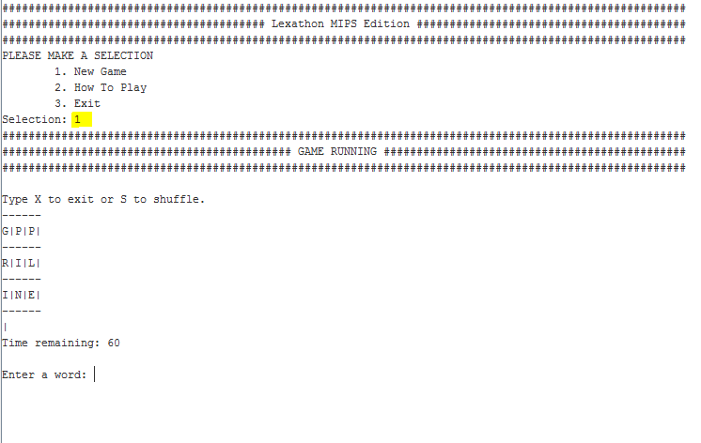

Type in 1 to play the game.

Type in 2 for How to Play

Type in 3 to exit the game.

4. When you are playing the game you can type in **X** to exit or **S** to shuffle.

5. Type in words that use the middle character in the grid to get points before the timer runs out.